07-03-2025

Deep learning DOCUMENTATION

# Perceptron

* Algorithm
* Supervised ml
* Mathematical model or function

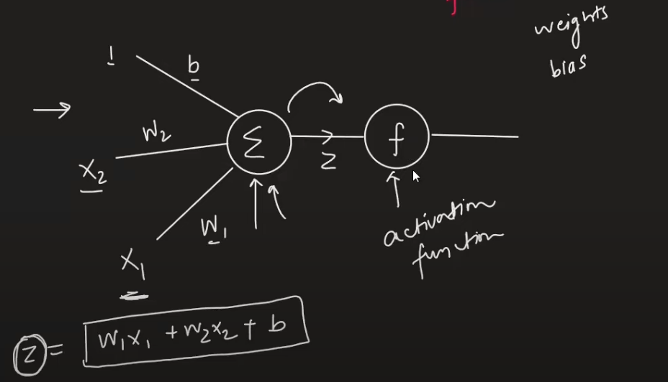

* Activation function is used to bring the value of z in some range like (0,1) or (-1,1)

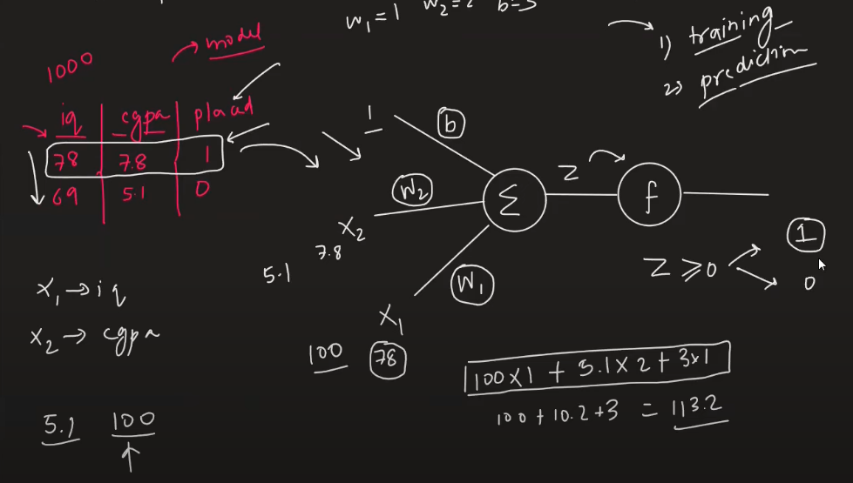

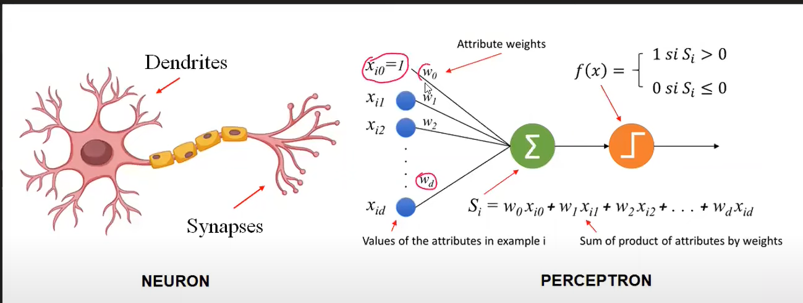

## Interpretation

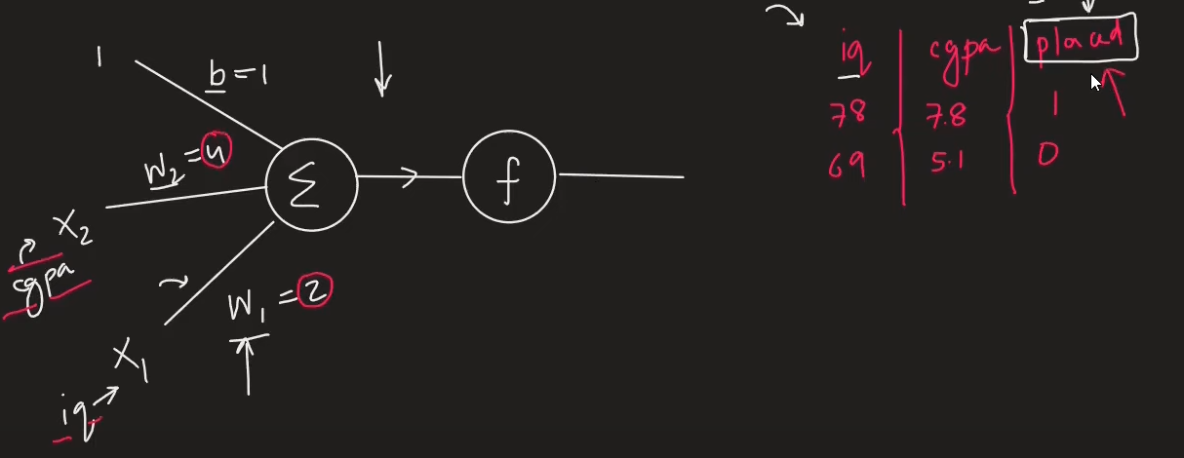

W1 and W2 are weights that explain what is the importance of feature to predict the outcome in our case iq and cgpa. {Feature Importances}

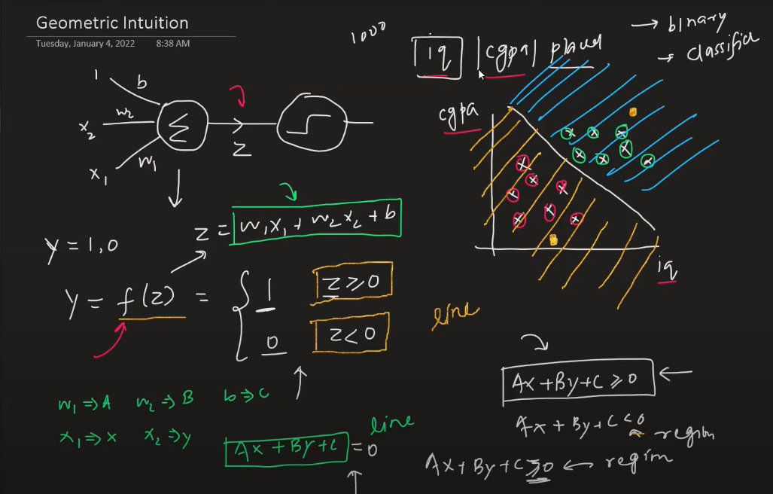

* 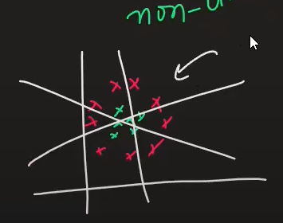Perceptron is like a line for creating a region and dividing the class. {Binary Classifier}
* For 2 d – line
* For 3 d – plane
* For 4 d onwards – hyperplane
* Limitation – works on linear or sort of linear only, perceptron will fail if u have nonlinear data
* E:\DeepLearning\1_Perceptron-Demo.ipynb

Check this file to clearly understand weight and b calculated nothing but m and c in line (y = mx+c)

# How to train a Perceptron

1 Using Perecptron trick

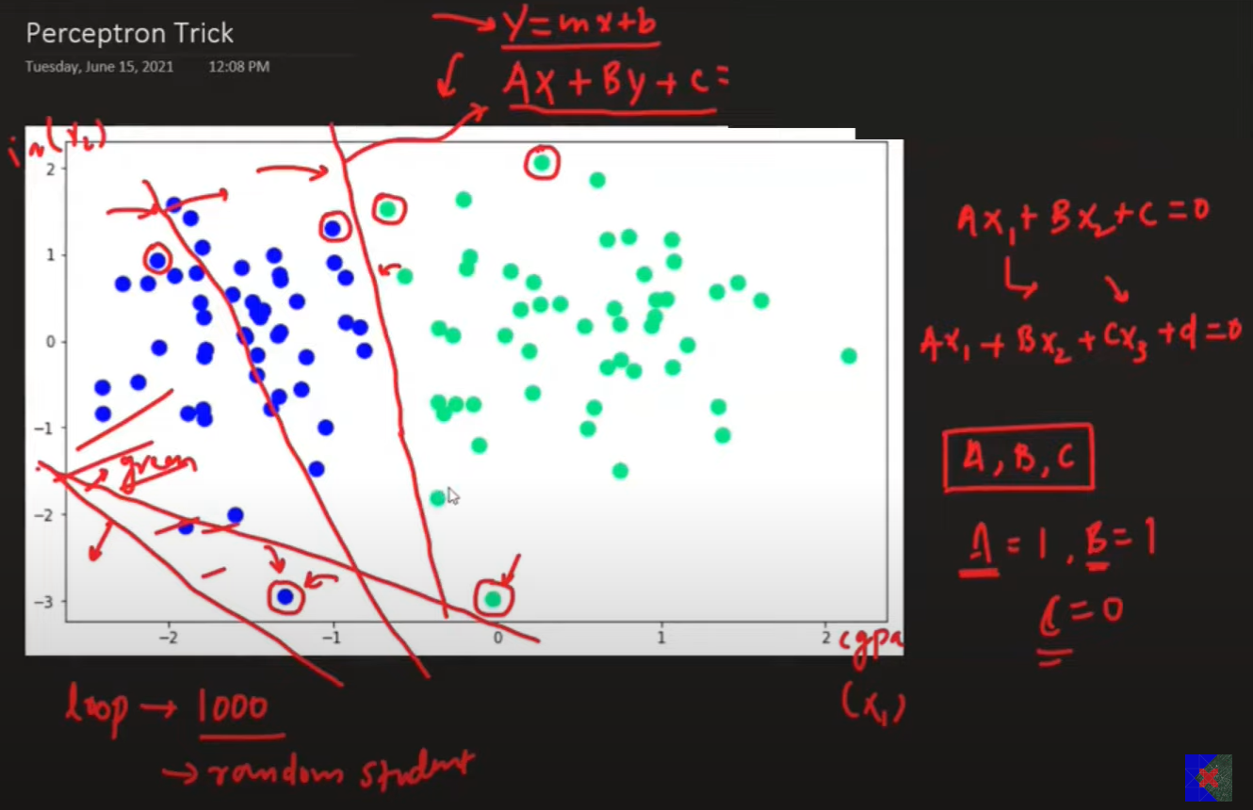 Run a loop for min 1000(epochs) time ask each point classified properly if yes then don’t change the line if no then change it.

Transformation

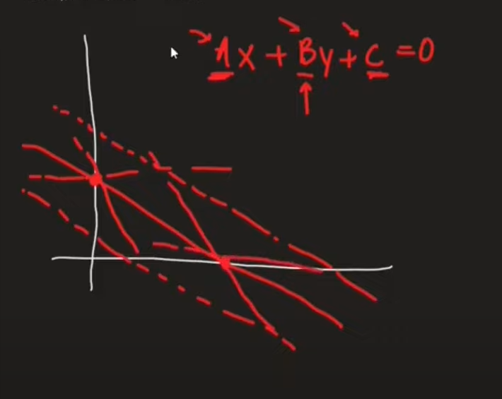If you change the value of c it is like moving upward or downward (c > then down c < up [dotted line])

Llly for a and b check in desmos tool

If a point is not correctly classified , based on the region you will add or subtract such that the line will correctly classify the point

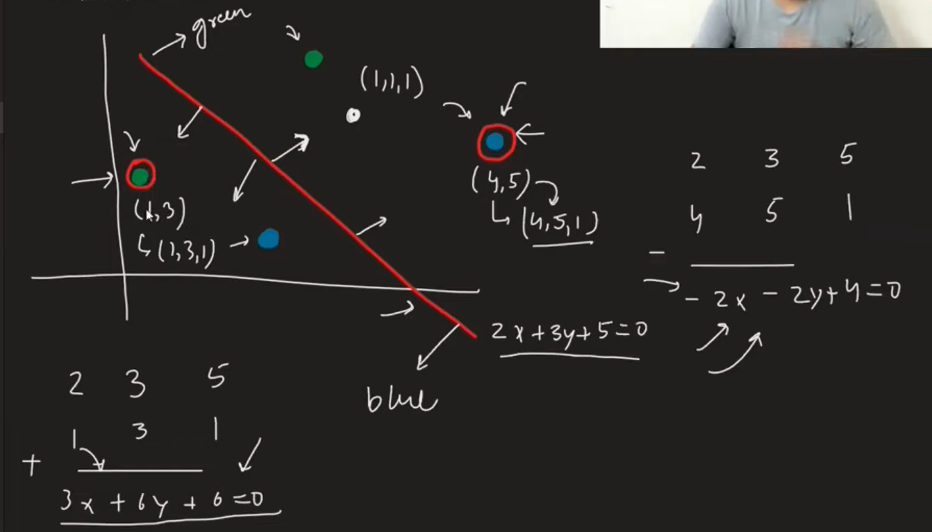

You usually don’t multiply directly the coefficient of line with the point , you multipy the point with learning rate usually 0.01 so that transformation happens in a such a way that points classify correctly.

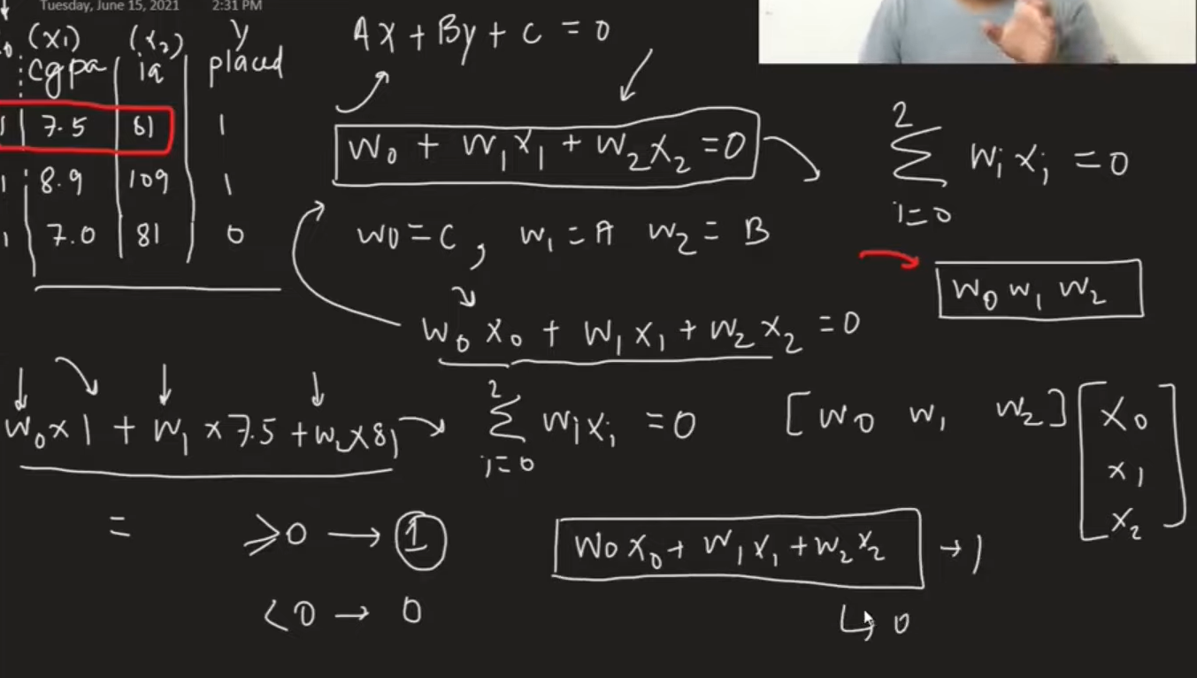

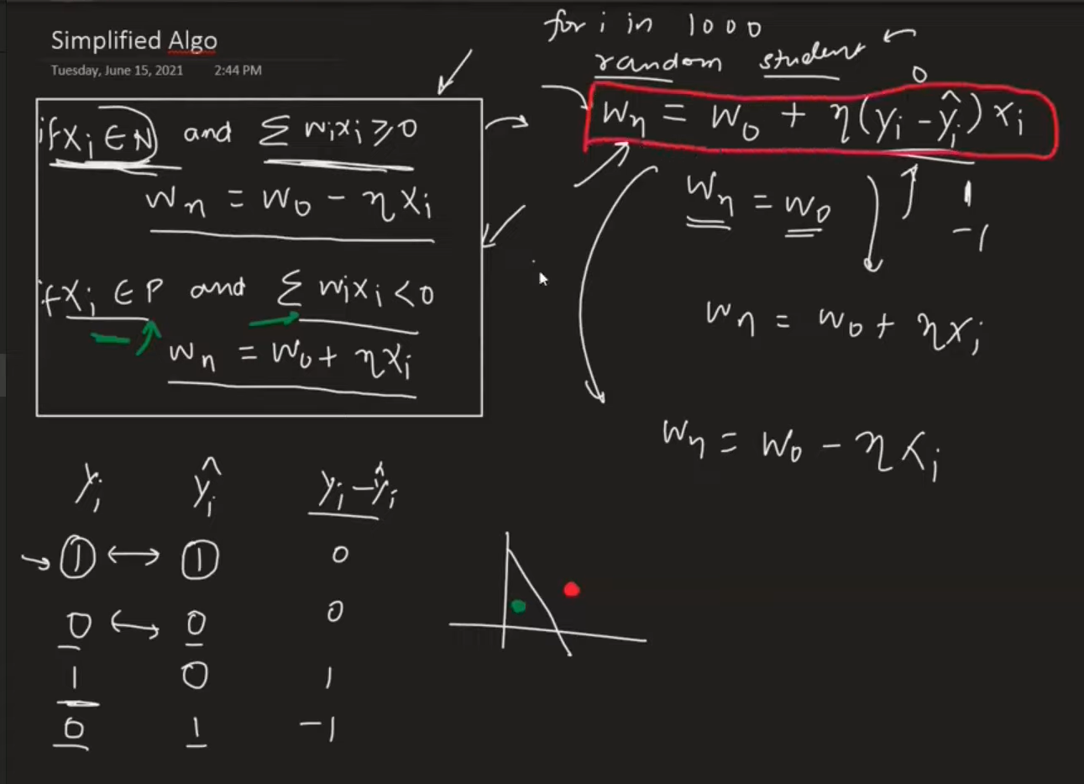

1. Perceptron Loss Function

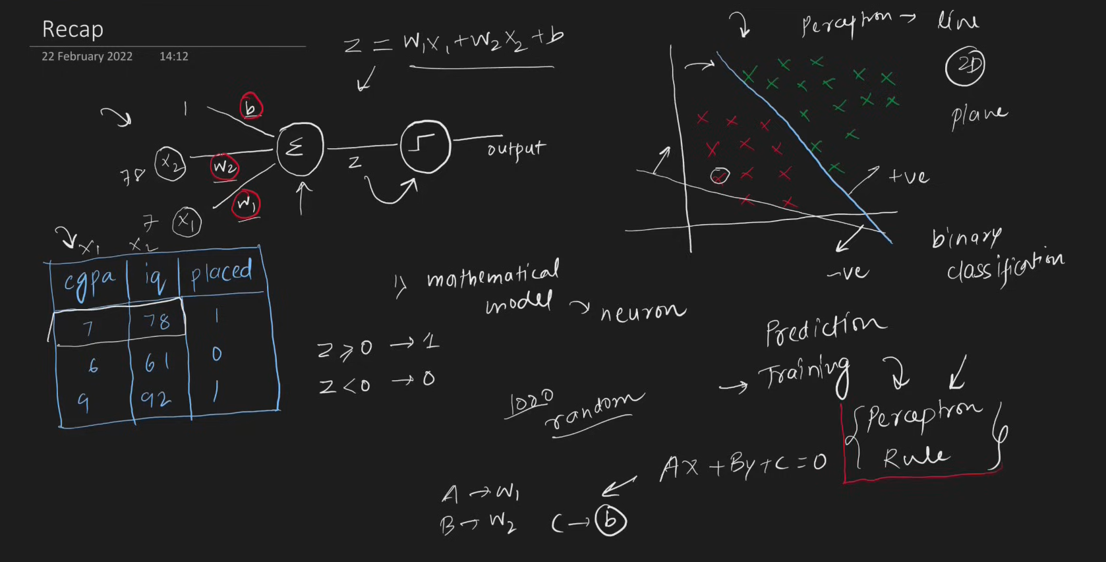

* Problem with perceptron trick
  + - If the value does not change in w1 ,w2 and b2 the line will not move or else the line will move if any changes
    - You can get any line and you cant quantify your result and you cant tell which line is best
    - Convergence problem possibility (like using same value for every epoch , it will not happen but there is a possibility )

Loss Function

* + - Is a way to tell that how the model is performing good or bad
    - It will give u a number that will tell how good is it
    - Simple term , it is a function which gives minimum value

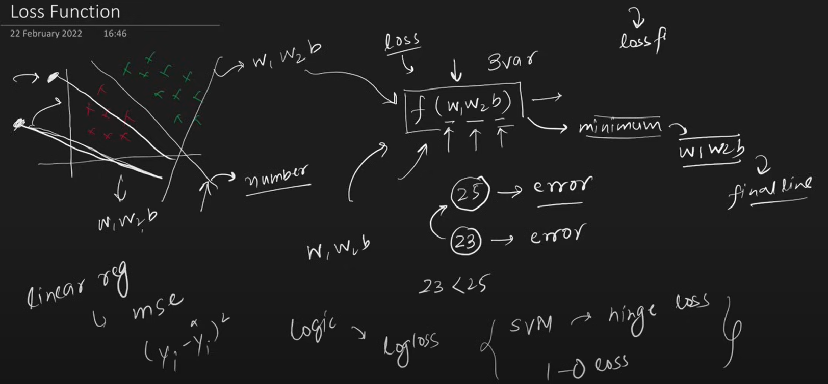

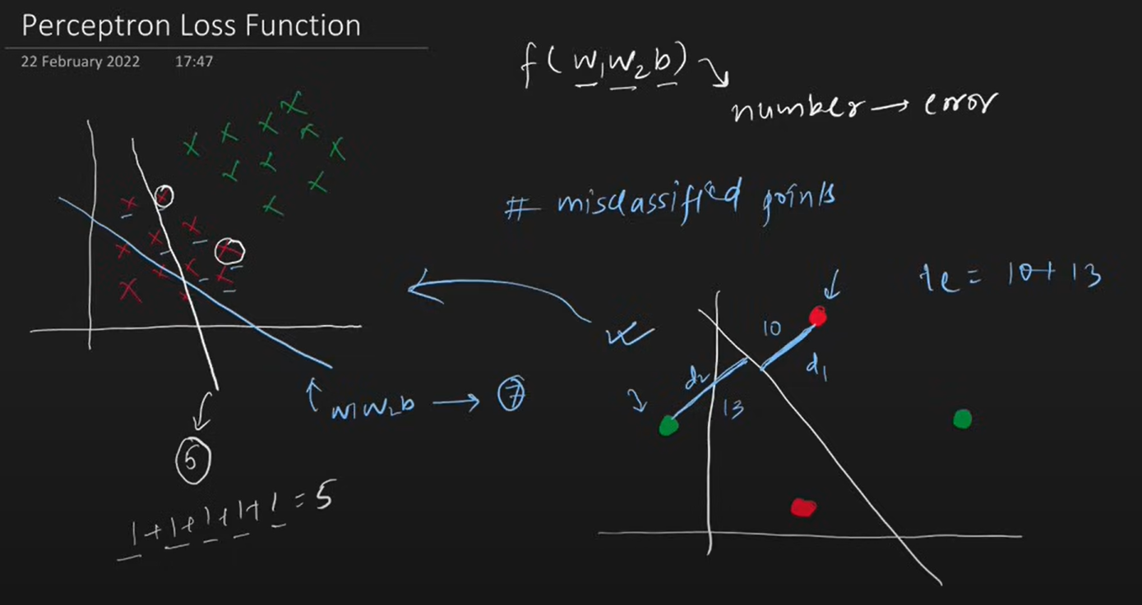

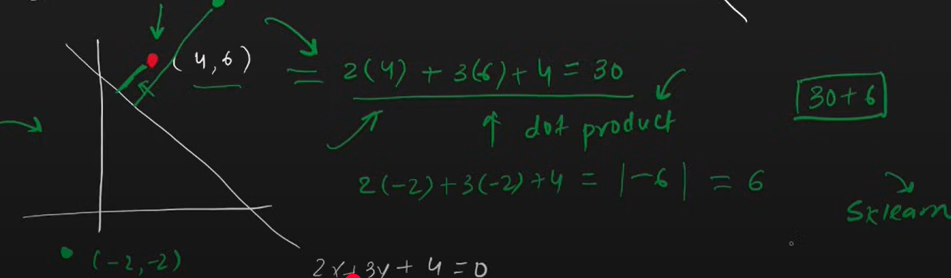

The Loss function implemented in sklearn for perceptron Is

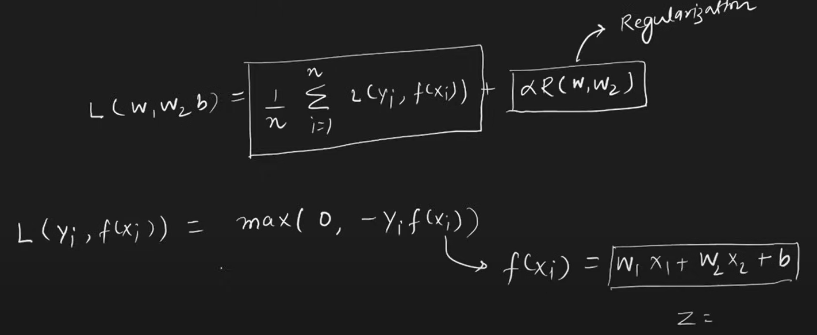

N – number of rows

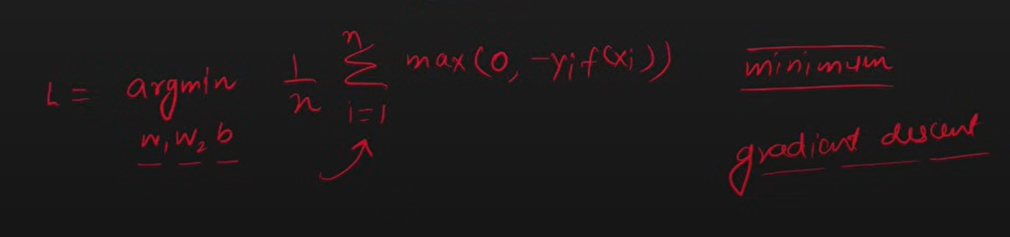

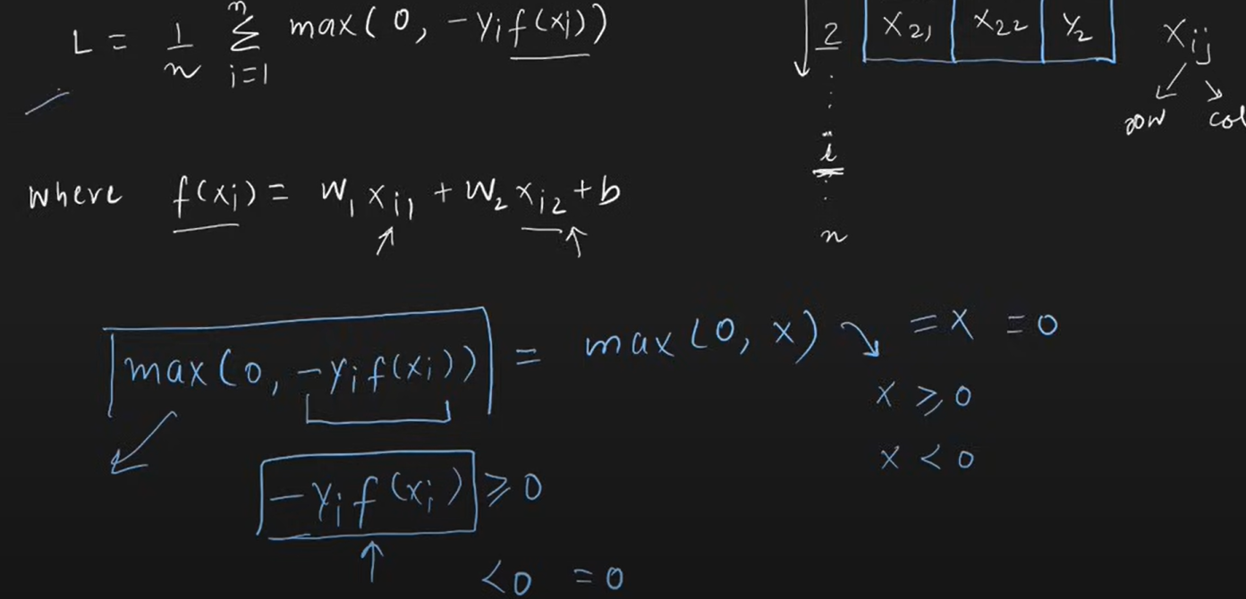

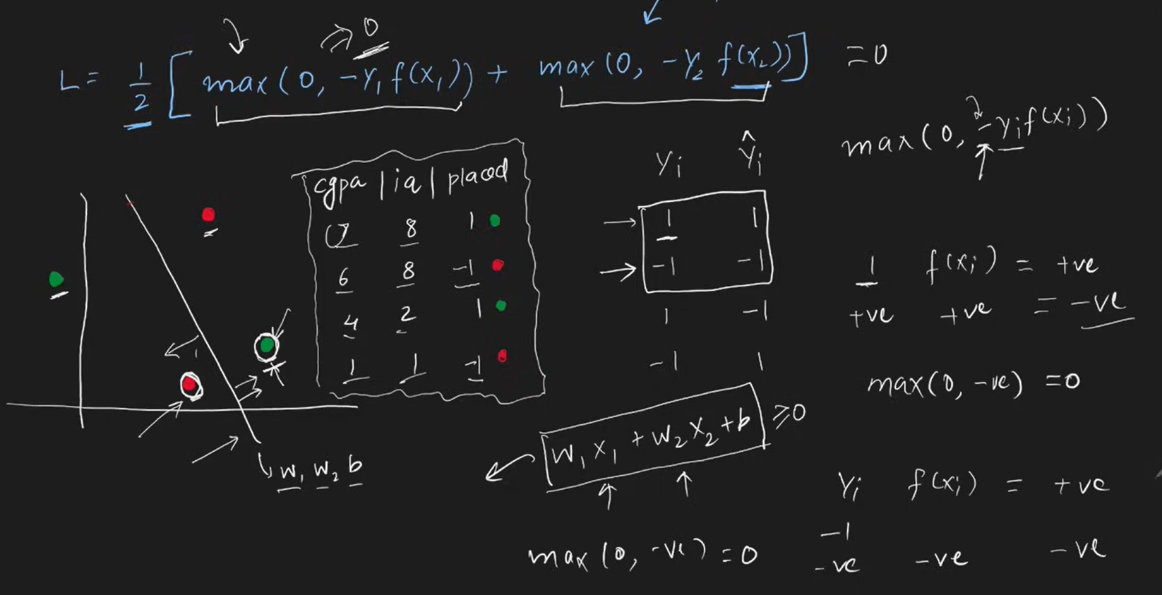

If point is correctly classified then that point does not contribute in the loss function

Gradient Descent Optimization Algorithm

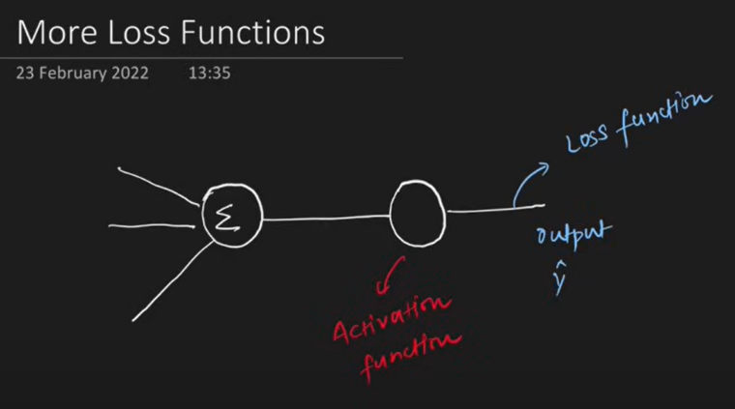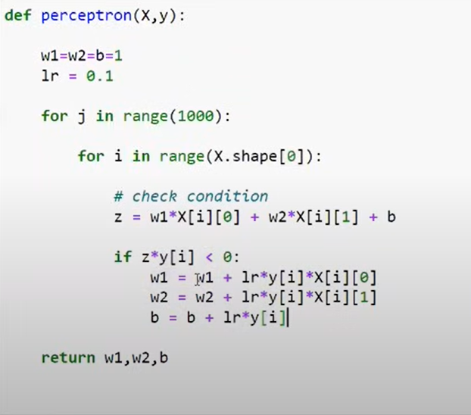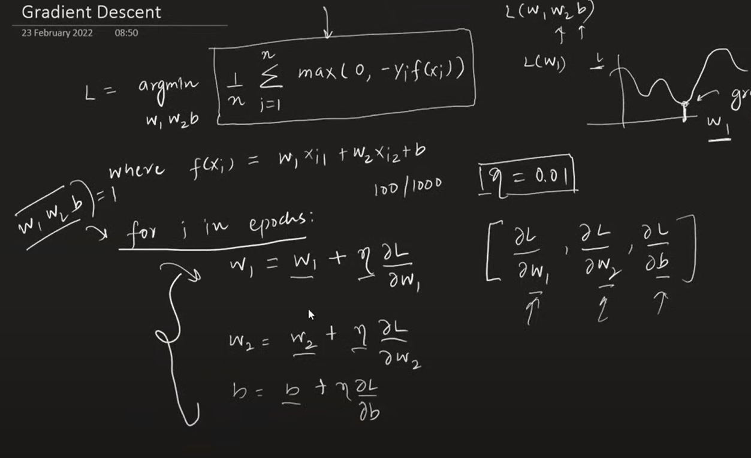

{ MORE FLEXIBLE ,MATHEMATICAL MODEL}

|  |  |  |
| --- | --- | --- |
| Activation Function | Loss Function | OUTPUT |
| STEP | Hinge Loss | 1,-1 (binary classifier) |
| SIGMOID | Binary Cross Entropy /log loss | 0,1 (binary classifier) |
| SOFTMAX | Categorical Cross Entropy | Multiclass prob |
| Linear | MSE | ANY NUMBER |

**NOTE**: PERCEPTRO IS ALSO CALLED AS LOGISITIC REGRESSION WHEN YOUR ACTIVATION FUNCTION IS SIGMOID AND LOSS IS BCE

# Problem with Perceptron

Works only with linear data not on non linear data because essentially perceptron is a linear model.

The problem with Perceptron lies in their limitation to learn complex patterns and functions, especially those that are not linearly separable. A Perceptron is a single-layer neural network with binary outputs, and it can only solve problems where the data points are linearly separable. If the data is not linearly separable, a Perceptron cannot converge and find a solution.

<https://playground.tensorflow.org/>